# Visual Studio Code User Manual

# Visual Studio Code Installation

1. Click the link: <https://code.visualstudio.com>

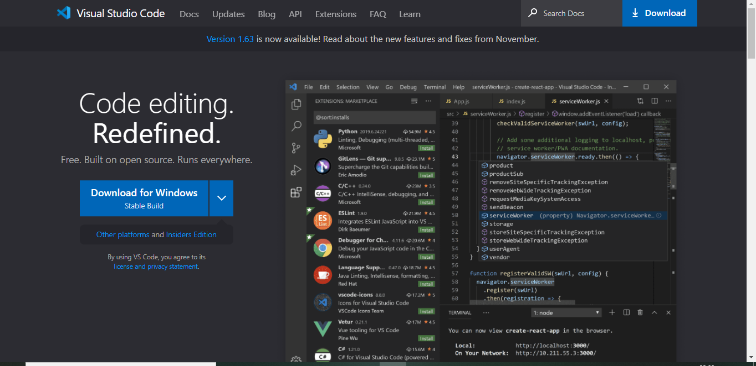

Click Download for Windows -> Executable file (51MB) gets downloaded

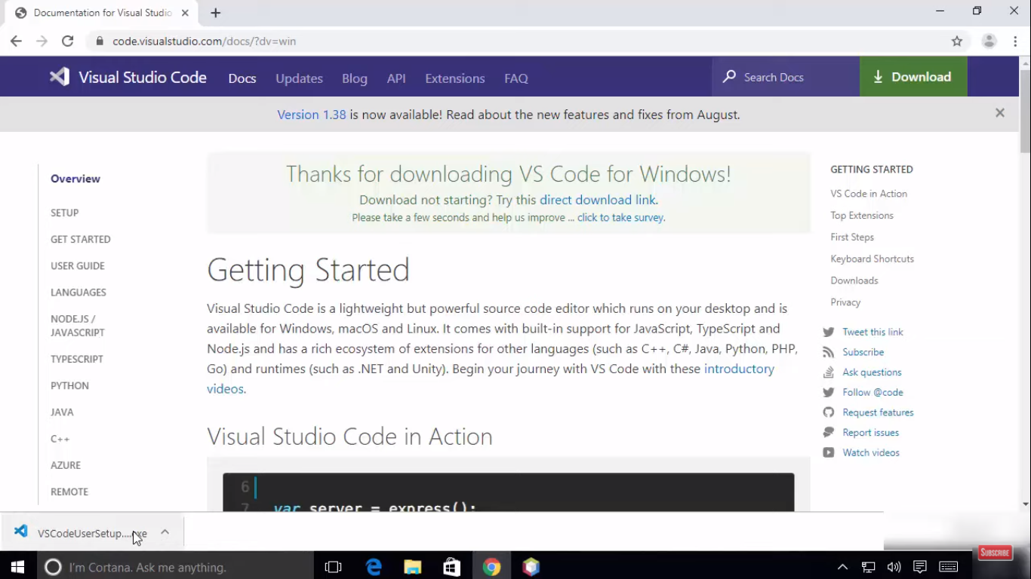

Open the Executable file -> Click Run

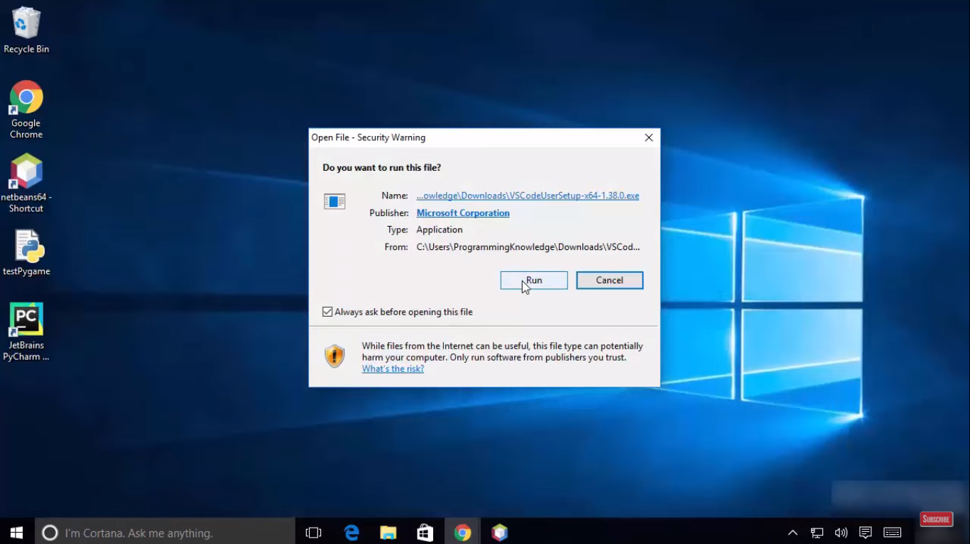

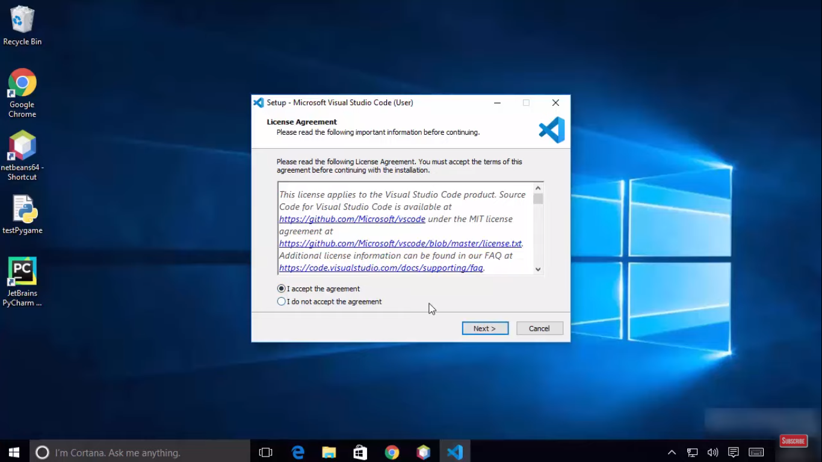

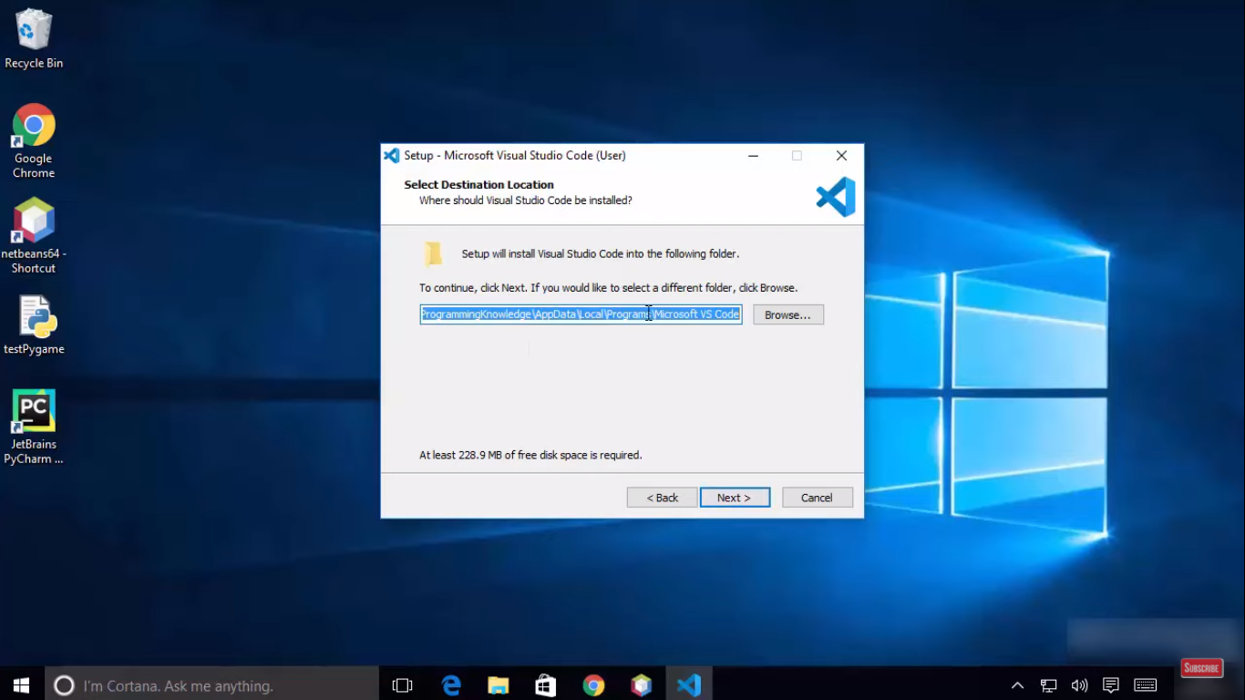

1. Do not check the ‘Don’t create a Start Menu’ checkbox, leave it unchecked -> Next

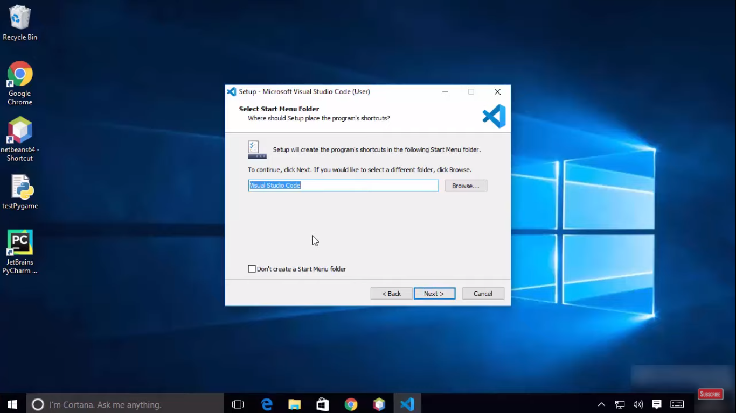

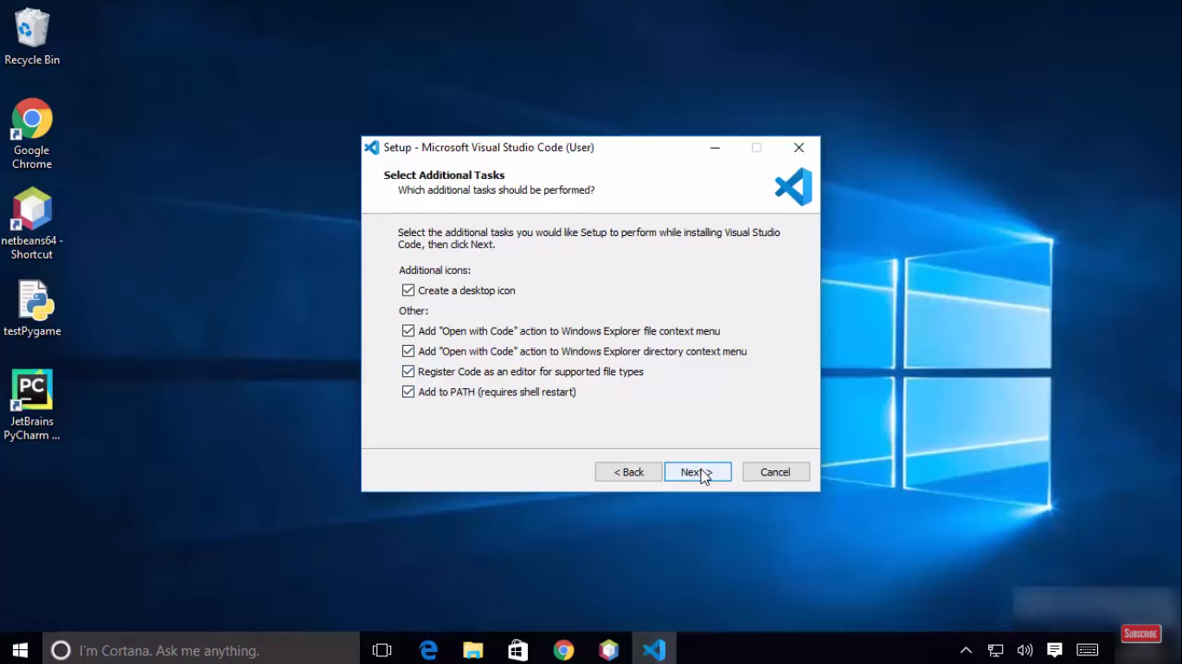

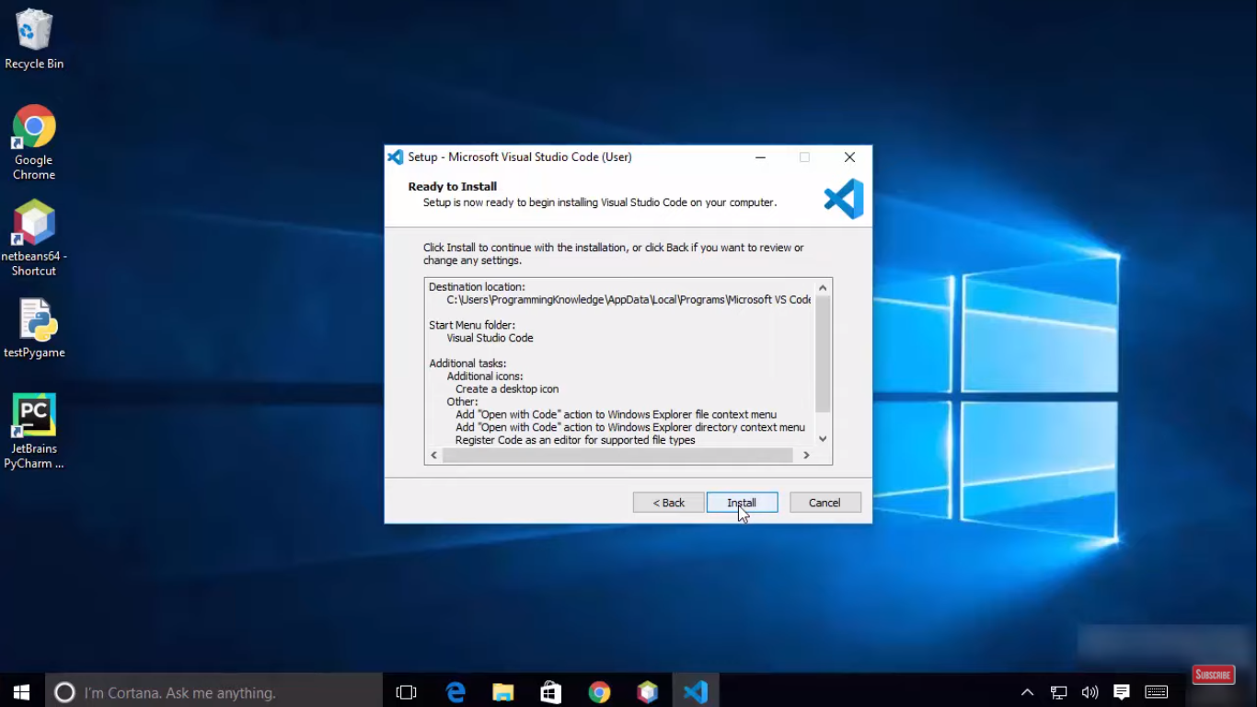

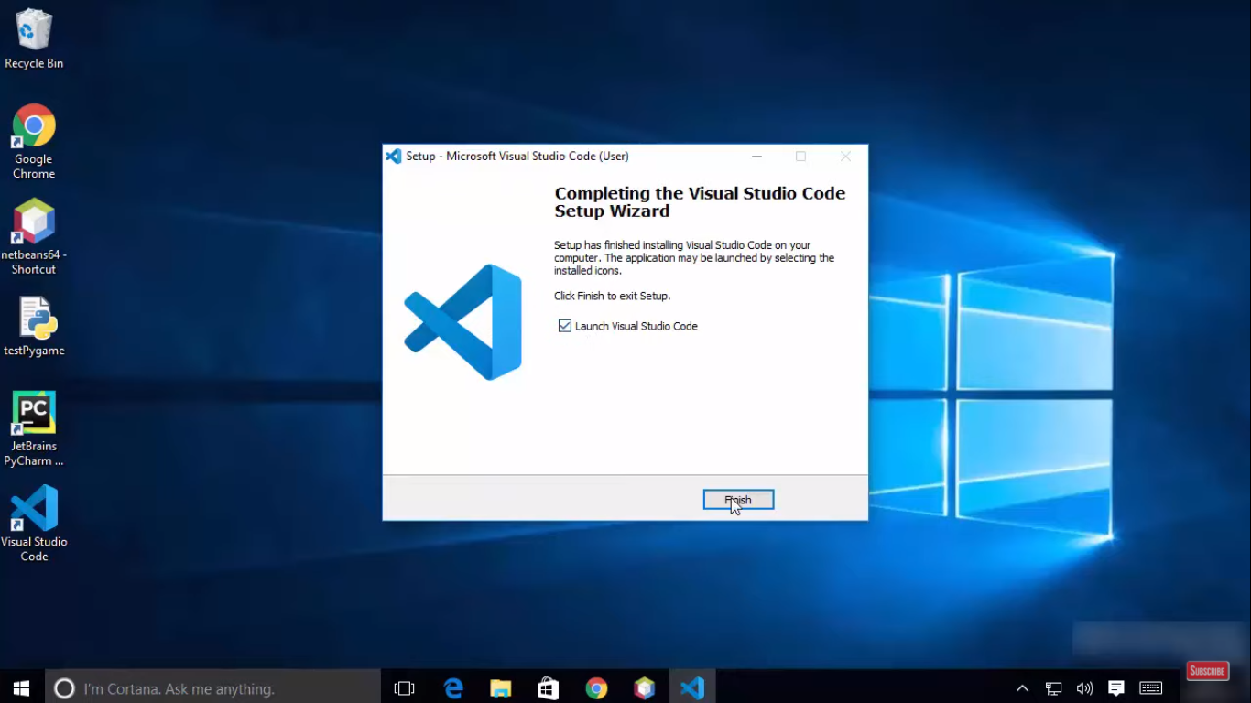

When execute a line in Visual Studio Code

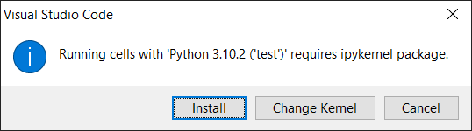

1. In VSCode, open Extensions -> Search Python -> Install

